Airplane Rides
Gain an entirely new vision of Campton by taking an aerial tour. Visitor or local, business or pleasure, the trip will change your view of the city
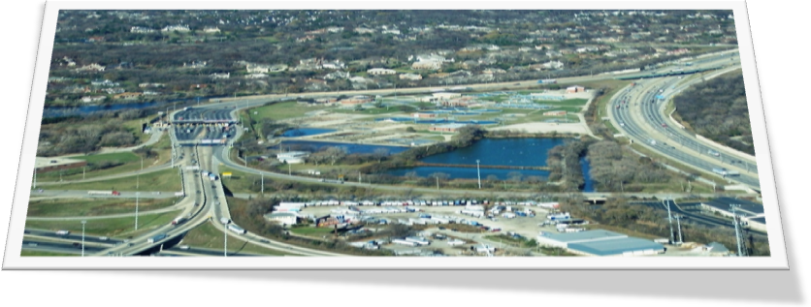

- Pilots are Licensed and experienced
- 15-,30-, or 60 minute tours available during daylight hours
- Individual and group rates

CALL SCENIC AIR AT 555-9883

